**SQL Lesson 1: SELECT queries 101**

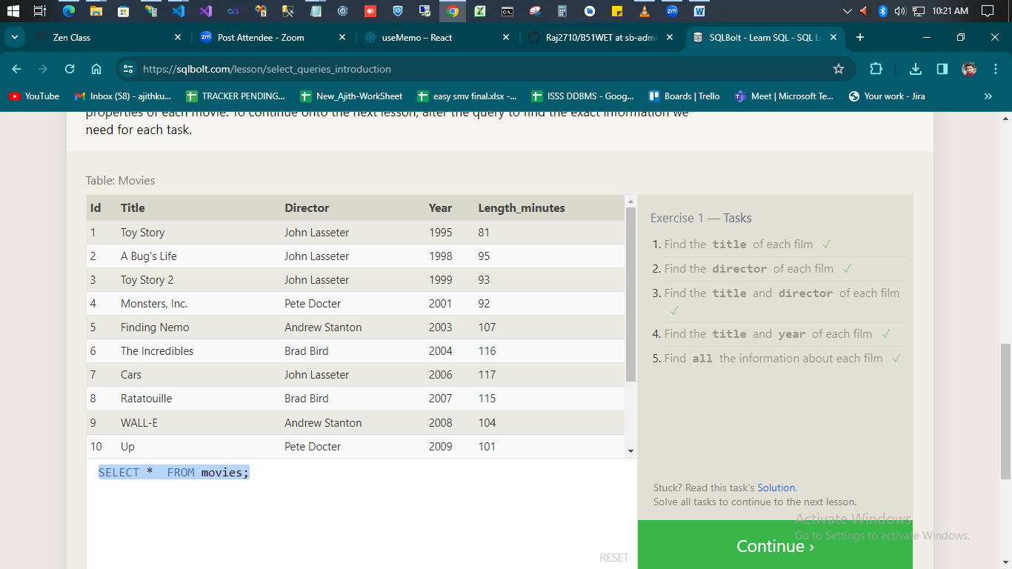

1. **Find the title of each film**

SELECT title FROM movies;

**2.Find the director of each film**

SELECT director FROM movies;

**3.Find the title and director of each film**

SELECT title , director FROM movies;

1. **Find the title and year of each film**

SELECT title , year FROM movies;

**5.Find all the information about each film**

SELECT * FROM movies;

**SQL Lesson 2: Queries with constraints (Pt. 1)**

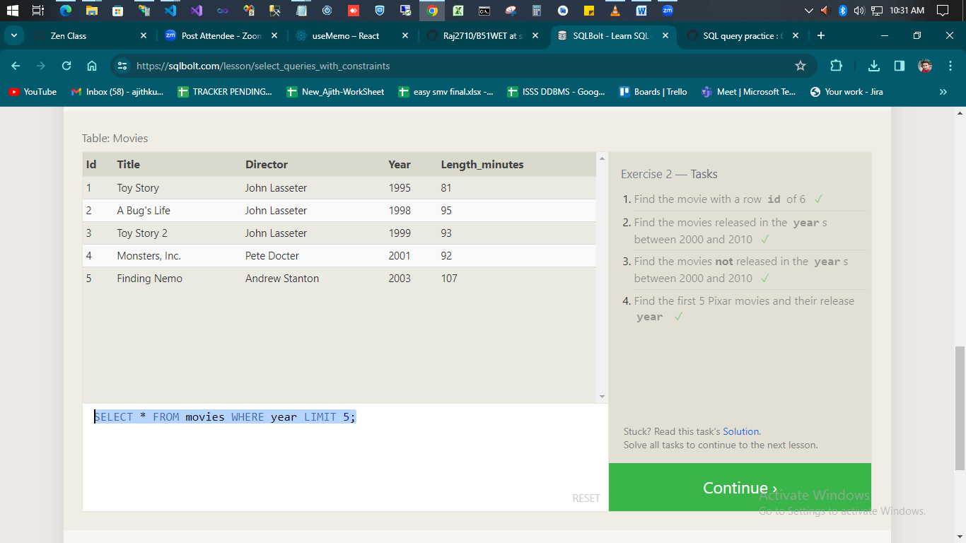

1. **Find the movie with a row id of 6**

SELECT * FROM movies where id=6

1. **Find the movies released in the years between 2000 and 2010**

SELECT * FROM movies where year between 2000 and 2010

1. **Find the movies not released in the years between 2000 and 2010**

SELECT * FROM movies where year not between 2000 and 2010

1. **Find the first 5 Pixar movies and their release year**

SELECT * FROM movies WHERE year LIMIT 5;

**SQL Lesson 3: Queries with constraints (Pt. 2)**

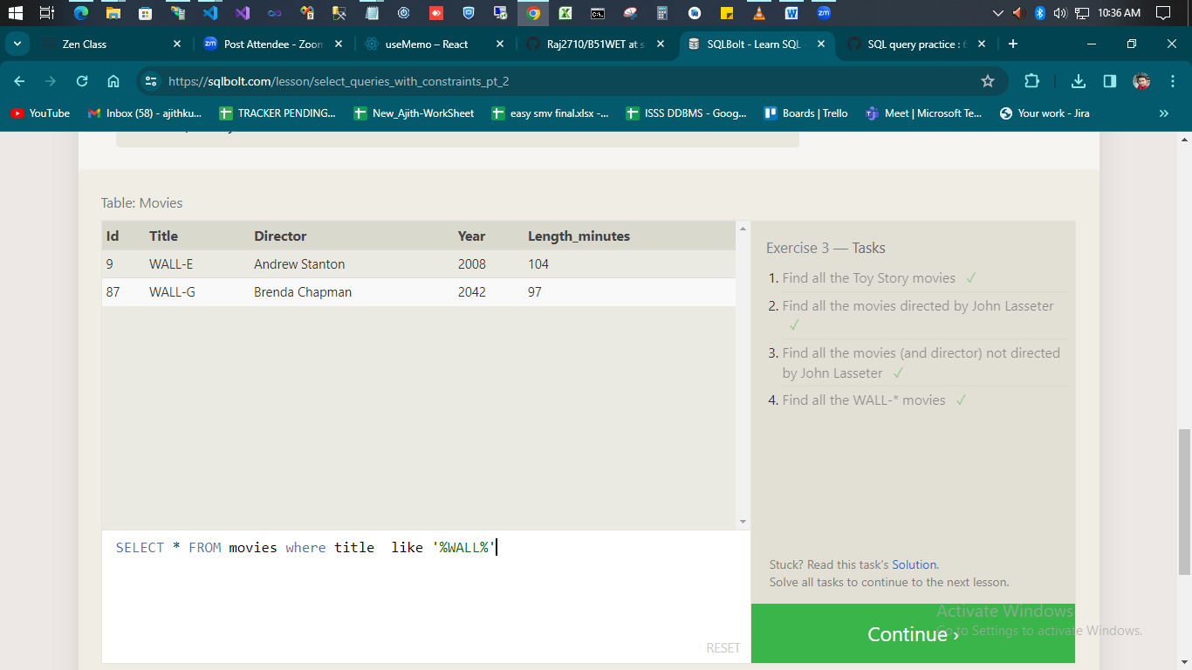

1. **Find all the Toy Story movies**

SELECT * FROM movies where title like '%Toy%'

1. **Find all the movies directed by John Lasseter**

SELECT * FROM movies where director like '%Lasseter%'

1. **Find all the movies (and director) not directed by John Lasseter**

SELECT * FROM movies where director not like '%Lasseter%'

1. **Find all the WALL-* movies**

SELECT * FROM movies where title like '%WALL%'

**SQL Lesson 4: Filtering and sorting Query results**

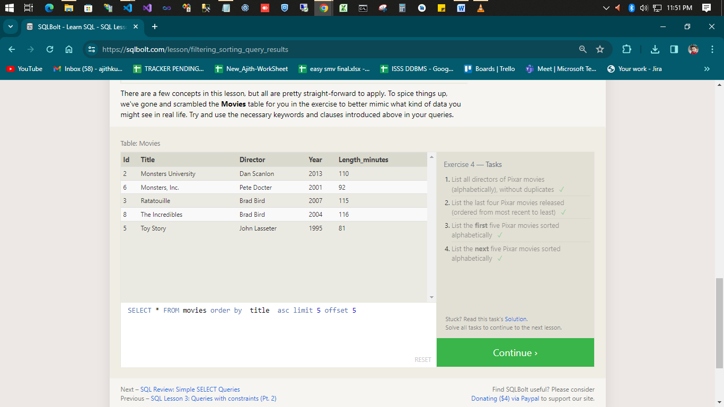

1. **List all directors of Pixar movies (alphabetically), without duplicates**

SELECT distinct director FROM movies order by director asc

1. **List the last four Pixar movies released (ordered from most recent to least)**

SELECT * FROM movies order by year desc limit 4

1. **List the first five Pixar movies sorted alphabetically**

SELECT * FROM movies order by title asc limit 5

1. **List the next five Pixar movies sorted alphabetically**

SELECT * FROM movies order by title asc limit 5 offset 5

**SQL Review: Simple SELECT Queries**

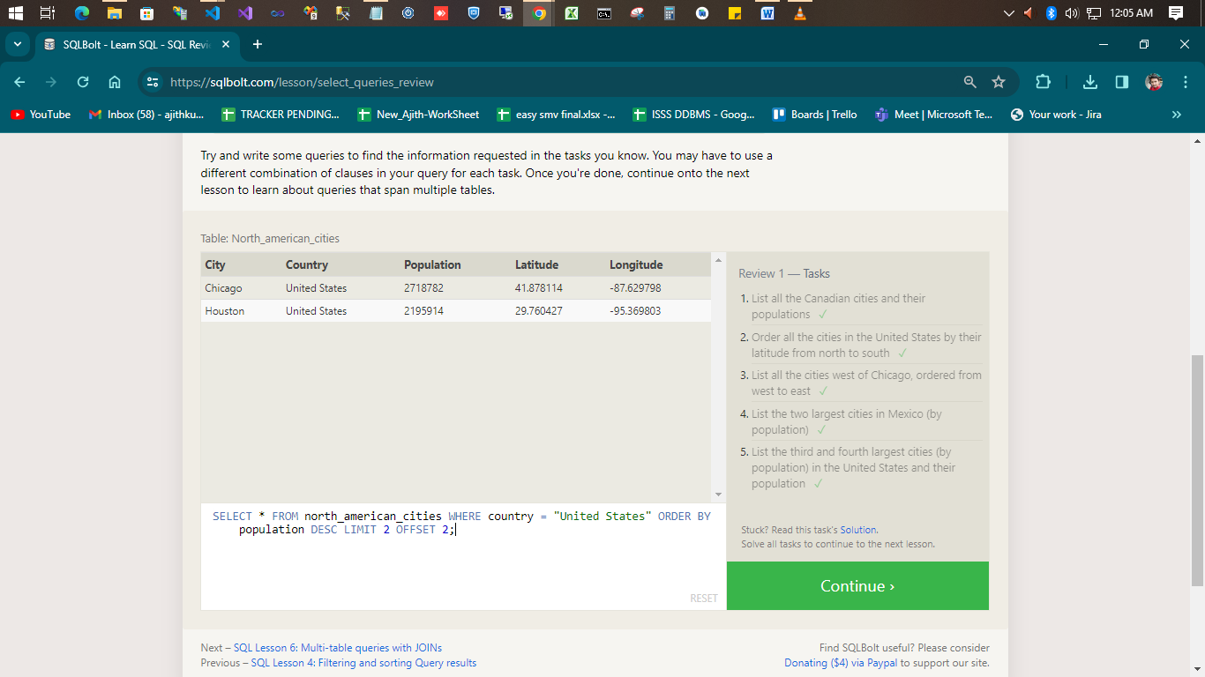

1. **List all the Canadian cities and their populations**

SELECT * FROM north_american_cities where country='Canada'

1. **Order all the cities in the United States by their latitude from north to south**

SELECT * FROM north_american_cities where country='United States' order by Latitude desc

1. **List all the cities west of Chicago, ordered from west to east**

SELECT * FROM north_american_cities where Longitude < -87.629798 order by Longitude asc

1. **List the two largest cities in Mexico (by population)**

SELECT * FROM north_american_cities WHERE country = ‘Mexico’ ORDER BY population DESC LIMIT 2;

1. **List the third and fourth largest cities (by population) in the United States and their population**

SELECT * FROM north_american_cities WHERE country = ‘United States’ ORDER BY population DESC LIMIT 2 OFFSET 2;

**SQL Lesson 6: Multi-table queries with JOINs**

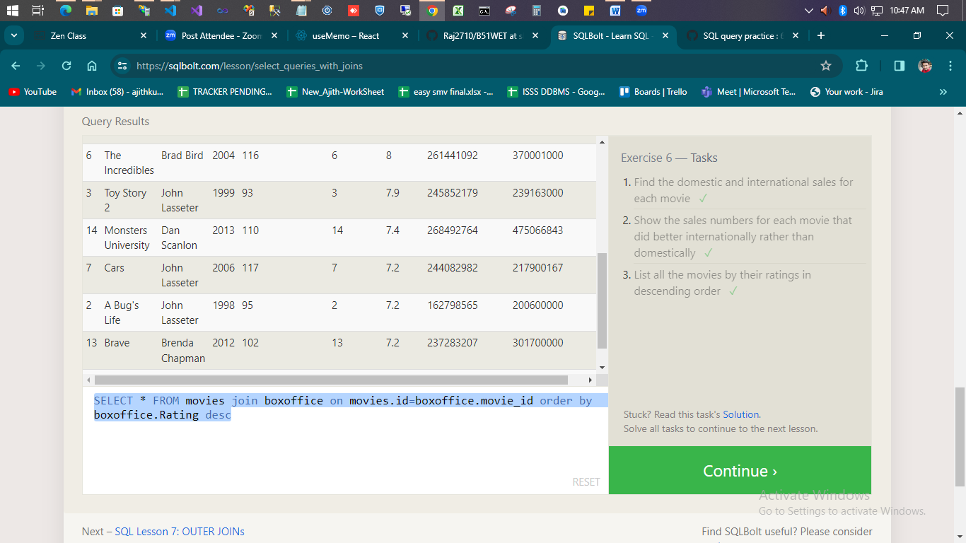

1. **Find the domestic and international sales for each movie**

SELECT * FROM movies join boxoffice on movies.id=boxoffice.movie_id

1. **Show the sales numbers for each movie that did better internationally rather than domestically**

SELECT * FROM movies join boxoffice on movies.id=boxoffice.movie_id where boxoffice.International_sales >=boxoffice.Domestic_sales

1. **List all the movies by their ratings in descending order**

SELECT * FROM movies join boxoffice on movies.id=boxoffice.movie_id order by

boxoffice.Rating desc

**SQL Lesson 7: OUTER JOINs**

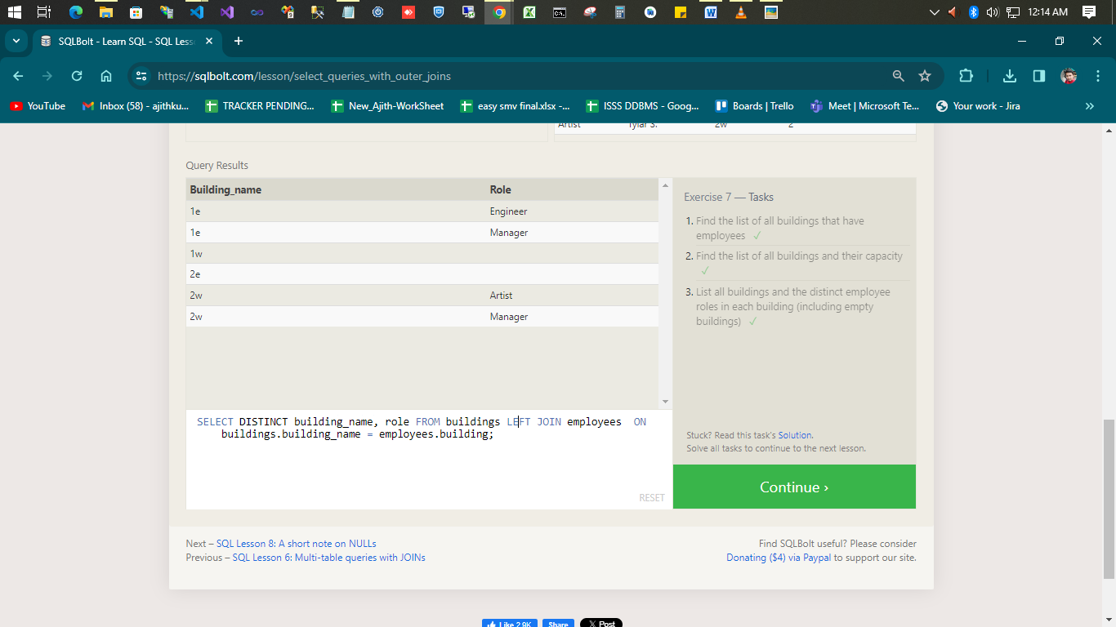

1. **Find the list of all buildings that have employees**

SELECT distinct Building FROM Employees ;

1. **Find the list of all buildings and their capacity**

SELECT * FROM Buildings

1. **List all buildings and the distinct employee roles in each building (including empty buildings)**

SELECT DISTINCT building_name, role FROM buildings LEFT JOIN employees ON buildings.building_name = employees.building;

**SQL Lesson 8: A short note on NULLs**

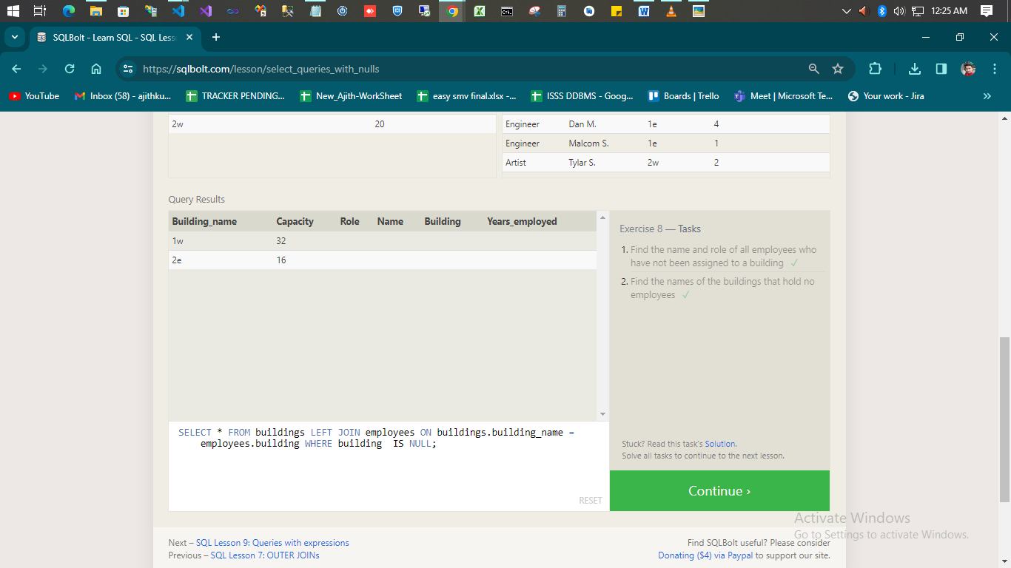

1. **Find the name and role of all employees who have not been assigned to a building**

SELECT * FROM employees WHERE buildings IS NULL;

1. **Find the names of the buildings that hold no employees**

SELECT * FROM buildings LEFT JOIN employees ON buildings.building_name = employees.building WHERE building IS NULL;

**SQL Lesson 9: Queries with expressions**

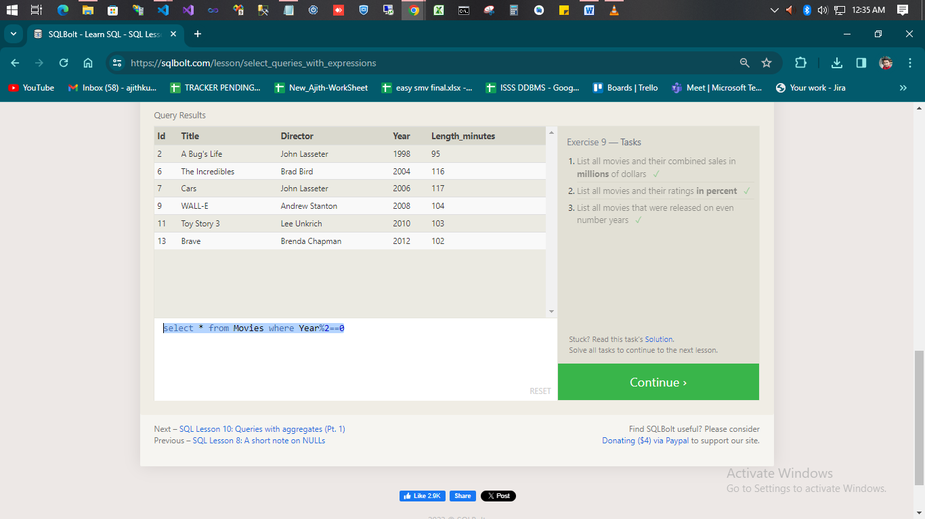

1. **List all movies and their combined sales in millions of dollars**

select id,title ,(Domestic_sales+International_sales)/1000000 as sales from movies join boxoffice on id=movie_id

1. **List all movies and their ratings in percent**

SELECT title, rating*10 AS ratings_percent FROM Movies JOIN Boxoffice ON Movies.id = Boxoffice.movie_id;

1. **List all movies that were released on even number years**

select * from Movies where Year%2==0

**SQL Lesson 10: Queries with aggregates (Pt. 1)**

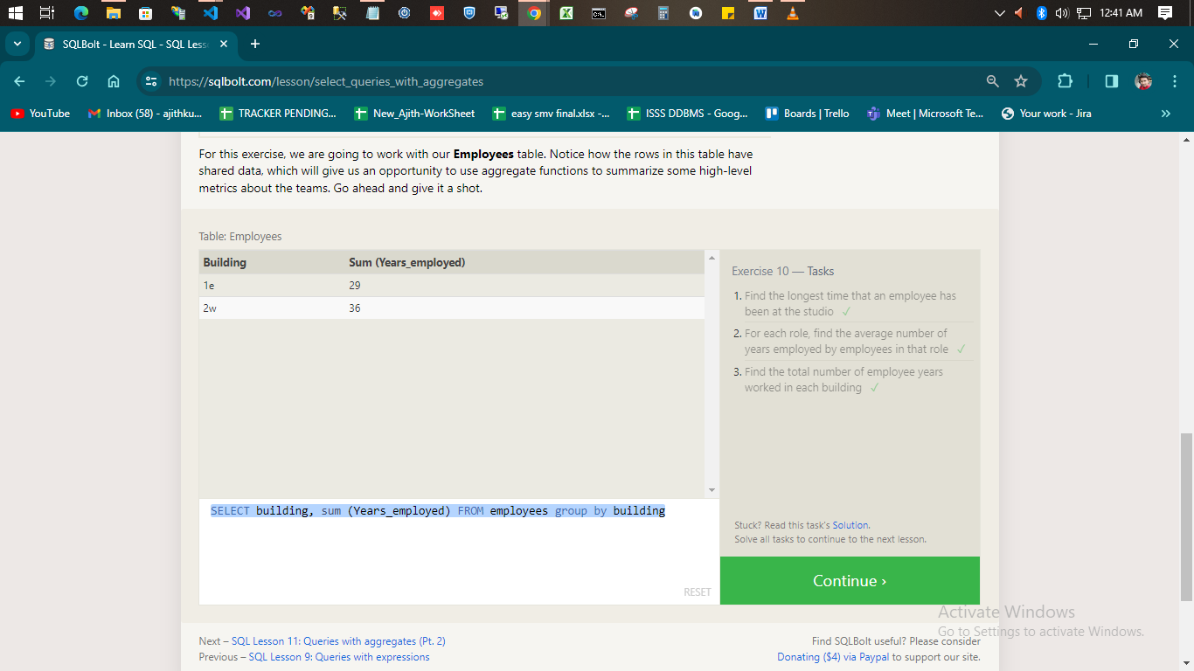

1. **Find the longest time that an employee has been at the studio**

SELECT max(Years_employed) FROM employees;

1. **For each role, find the average number of years employed by employees in that role**

SELECT role, avg(Years_employed) FROM employees group by role

1. **Find the total number of employee years worked in each building**

SELECT building, sum (Years_employed) FROM employees group by building

**SQL Lesson 11: Queries with aggregates (Pt. 2)**

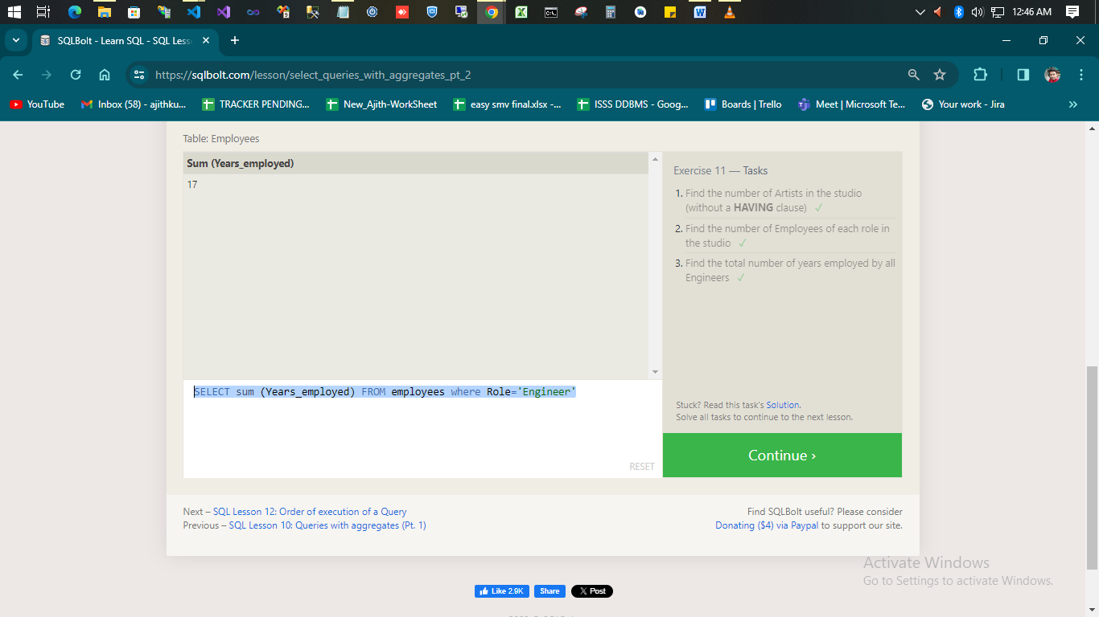

1. **Find the number of Artists in the studio (without a HAVING clause)**

SELECT count(*) FROM employees where Role='Artist'

1. **Find the number of Employees of each role in the studio**

SELECT role,count(*) FROM employees group by Role

1. **Find the total number of years employed by all Engineers**

SELECT sum (Years_employed) FROM employees where Role='Engineer'

**SQL Lesson 12: Order of execution of a Query**

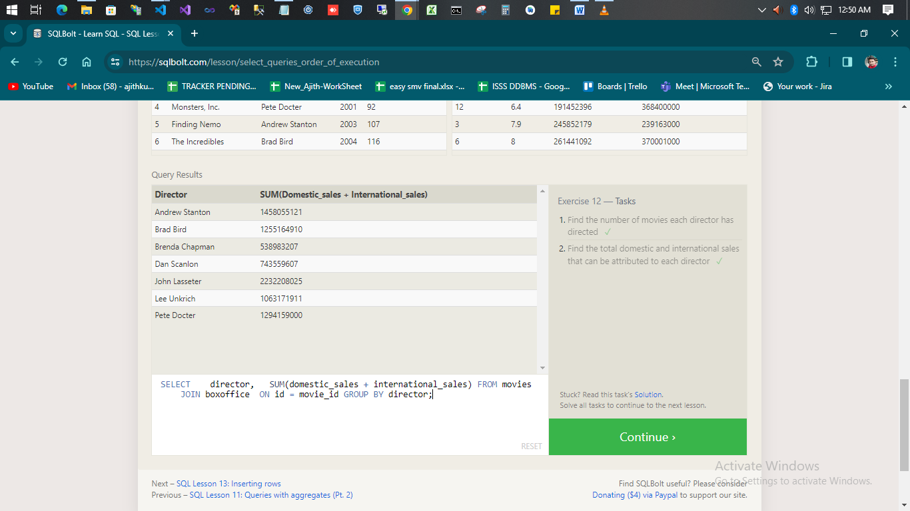

1. **Find the number of movies each director has directed**

SELECT director,COUNT(*) FROM movies GROUP BY director;

1. **Find the total domestic and international sales that can be attributed to each director**

SELECT director, SUM(domestic_sales + international_sales) FROM movies JOIN boxoffice ON id = movie_id GROUP BY director;

**SQL Lesson 13: Inserting rows**

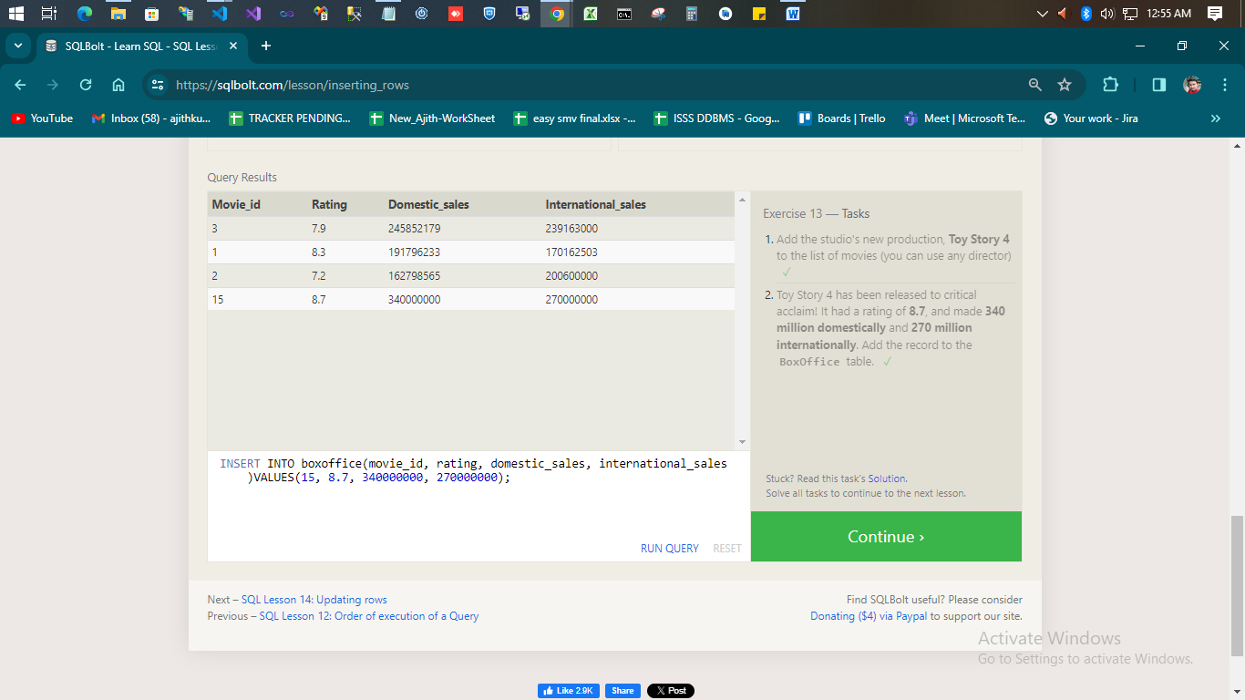

1. **Add the studio's new production, Toy Story 4 to the list of movies (you can use any director)**

INSERT INTO movies (title, director, year, length_minutes)VALUES ('Toy Story 4', 'Lance Lafontaine', 2984, 15);

1. **Toy Story 4 has been released to critical acclaim! It had a rating of 8.7, and made 340 million domestically and 270 million internationally. Add the record to the BoxOffice table.**

INSERT INTO boxoffice(movie_id, rating, domestic_sales, international_sales)VALUES(15, 8.7, 340000000, 270000000);

**SQL Lesson 14: Updating rows**

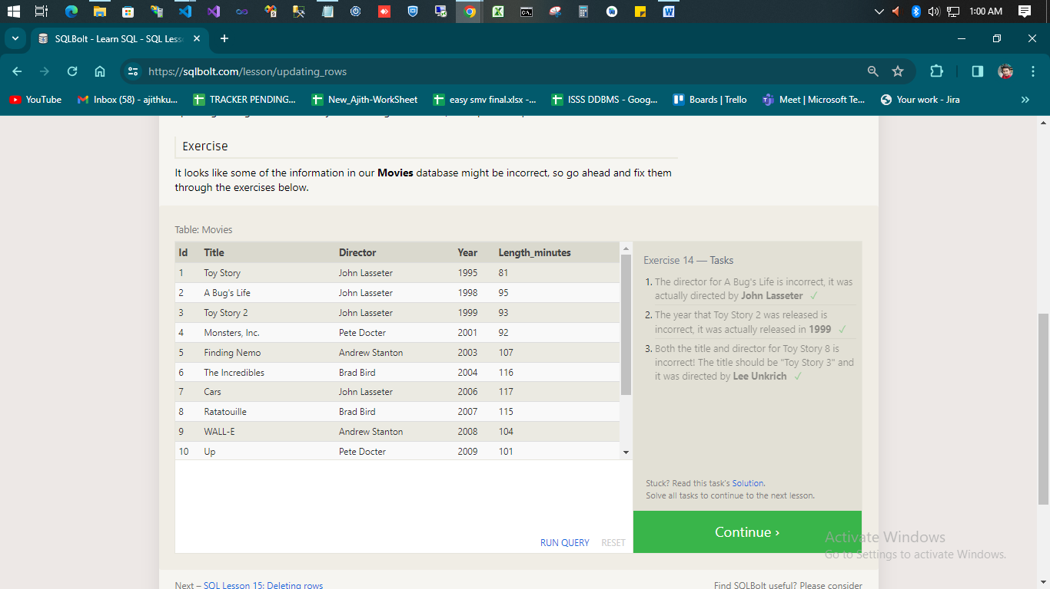

1. **The director for A Bug's Life is incorrect, it was actually directed by John Lasseter**

UPDATE movies SET director = ‘John Lasseter’ WHERE title = ‘A Bug's Life’;

1. **The year that Toy Story 2 was released is incorrect, it was actually released in 1999**

Update Movies set Year = 1999 where Title = 'Toy Story 2';

1. **Both the title and director for Toy Story 8 is incorrect! The title should be "Toy Story 3" and it was directed by Lee Unkrich**

Update Movies set Title = 'Toy Story 3', Director = 'Lee Unkrich' where Title = 'Toy Story 8';

**SQL Lesson 15: Deleting rows**

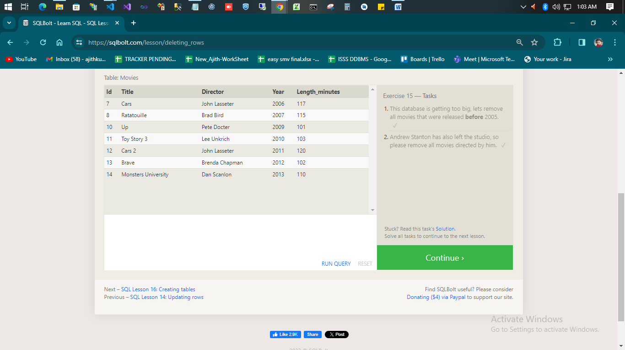

1. **This database is getting too big, lets remove all movies that were released before 2005.**

Delete from movies where Year < 2005;

1. **Andrew Stanton has also left the studio, so please remove all movies directed by him.**

Delete from movies where Director = 'Andrew Stanton';

**SQL Lesson 16: Creating tables**

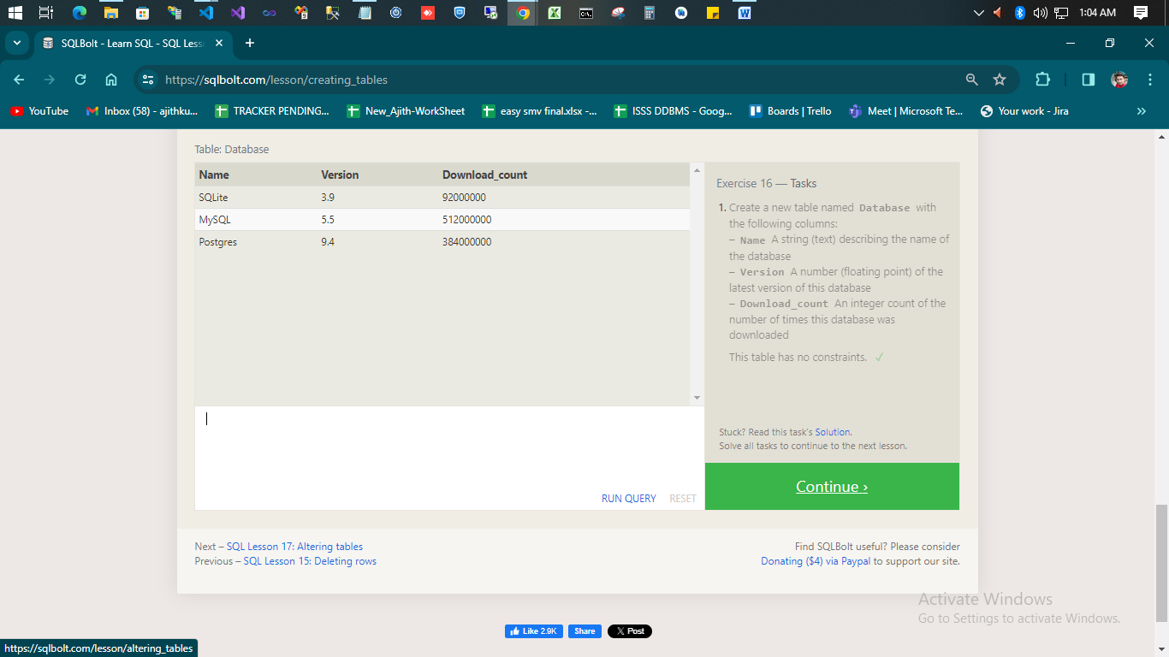

1. **Create a new table named Database with the following columns: – Name A string (text) describing the name of the database**

Create table Database(Name Varchar(20), Version FLOAT, Download_count int);

**SQL Lesson 17: Altering tables**

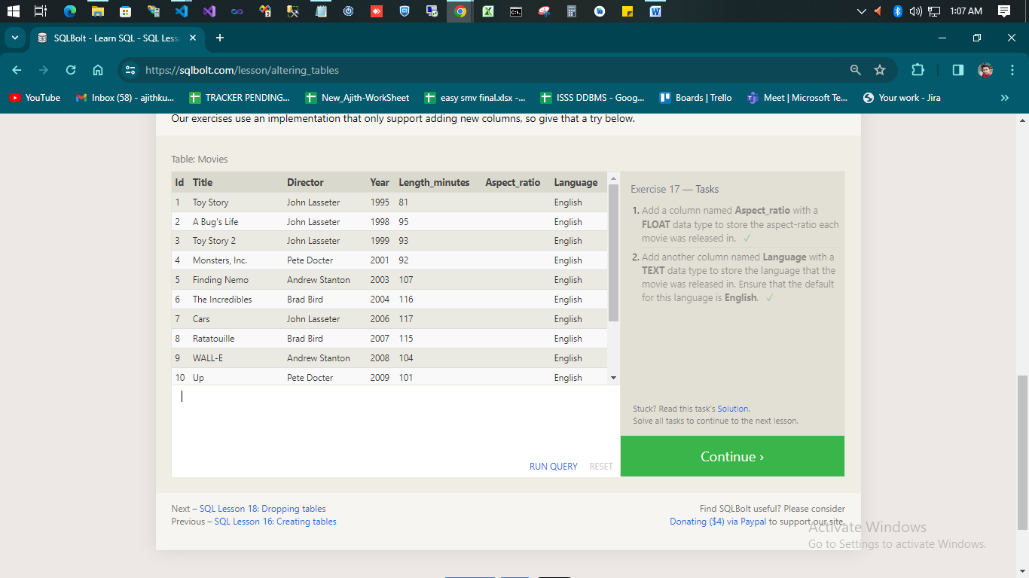

1. **Add a column named Aspect_ratio with a FLOAT data type to store the aspect-ratio each movie was released in.**

Alter table Movies add Aspect_ratio float;

1. **Add another column named Language with a TEXT data type to store the language that the movie was released in. Ensure that the default for this language is English**.

Alter table Movies add Language varchar(20) default 'English';

**SQL Lesson 18: Dropping tables**

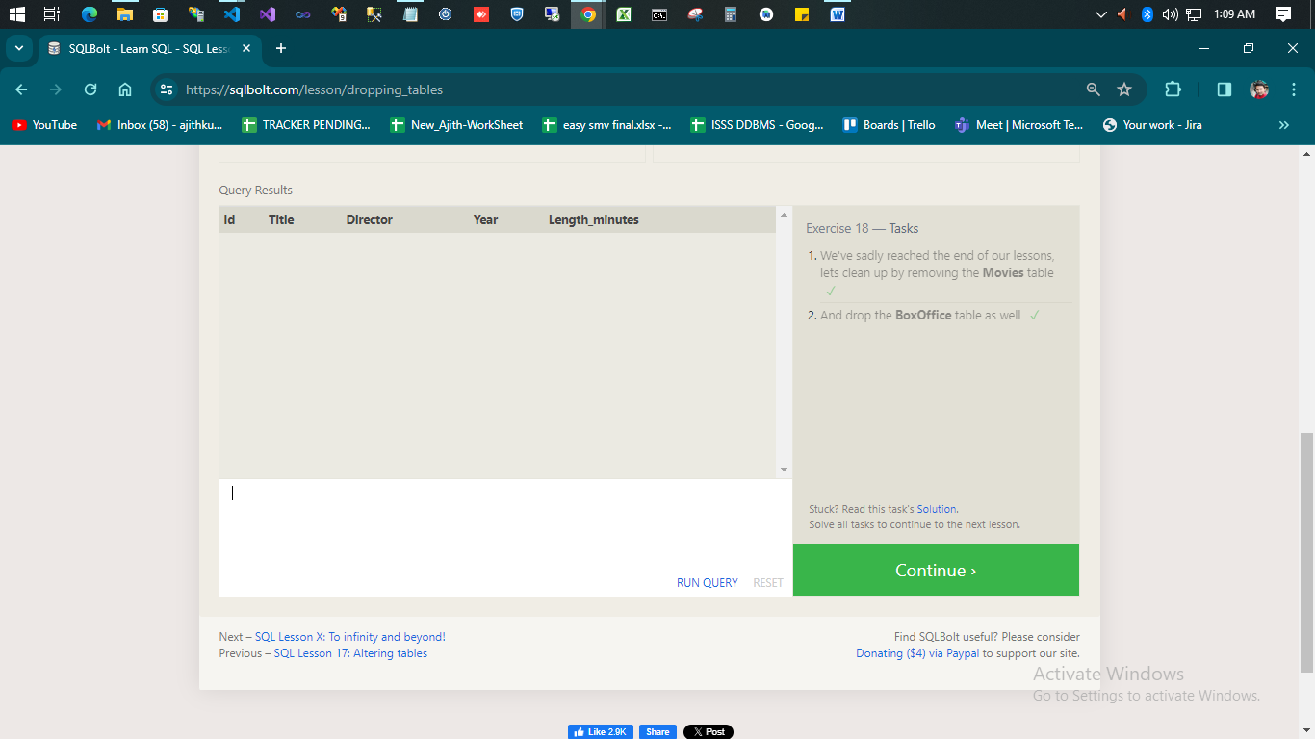

1. **We've sadly reached the end of our lessons, lets clean up by removing the Movies table;**

Drop table Movies

1. **And drop the BoxOffice table as well**

Drop table BoxOffice